JOB OVERVIEW
NAME | GOLDY GODFREY EFFIONG
POSITION | HUMAN RESOURCES EXECUTIVE
DEPARTMENT | HUMAN RESOURCES DEPARTMENT
REPORTING LINE | HEAD OF HUMAN RESOURCES

JOB RESPONSIBILITY
CORE FUNCTIONS | - Maintaining personnel records.  - Updating the database with new hires' information.  - Assisting in the hiring process  - Gathering all payroll data- leave allowance, penalties, sanctions, & loan.  - Schedule job interviews & contact candidates as needed  - Collate reports on HR related metrics like the total number of hires and exits.  - Preparing employment contract documents  - Attend to staff HR related issues  - HMO relationship with providers  - Preparation of staff's monthly payroll  - Part of the disciplinary committee  - Maintaining department records and reports  - Participating in administrative staff meetings.  - Maintaining the company directory and other organizational charts.  - Ensuring all statutory requirements are timely processed.

KEY PERFORMANCE INDICATORS
- People Management & Conflict Resolution, i.e., the percentage of resolved conflicts
- Resolve 90% of employee grievances within 5 working days within the next 6 months.
- Achieve a conflict resolution rate of 90% or better, with no unresolved conflicts lasting more than 30 days within the next 12 months.

- Performance Management
- Ensuring 100% compliance regarding the quarterly performance review
- Execution of the result of the bi-annual performance appraisal on or before the 2nd week of the next half-year

- Recruitment and Retention
- Reduce the overall employee turnover rate to 10% or less within the next 12 months
- Time-to-Hire: Reduce average time (2months) taken to fill open positions within the next 12months
- Onboarding: Within one week of resumption
- Ensure employees receive confirmation letters by the first week of the 7th month.

- Payroll Management and Statutory Compliance
- Achieve a payroll accuracy rate of 99.5% or better, with no more than 0.5% errors in payroll processing within the next 6 months
- Ensure a monthly schedule of all (Pension, Tax, NSITF, etc.) statutory payments on or before the last day of every month.
- Ensure submission of payroll approval for salaries on the 22nd of the month.
- Ensure payment of monthly salaries on the 26th of the month for all staff and on the 24th for NBC.

- Employee Engagement and Satisfaction
- Bi-annual Execution of Employee Satisfaction Survey – Timeline 3weeks
- Ensure 75% participation rate in the surveys
- Achieve a 75% engagement score by the end of the year.

- Exit Management
- Average Time-to-Exit: Average time taken to complete the exit process.
- Exit Process Completion Rate: Percentage of exit processes completed within a specified timeframe.

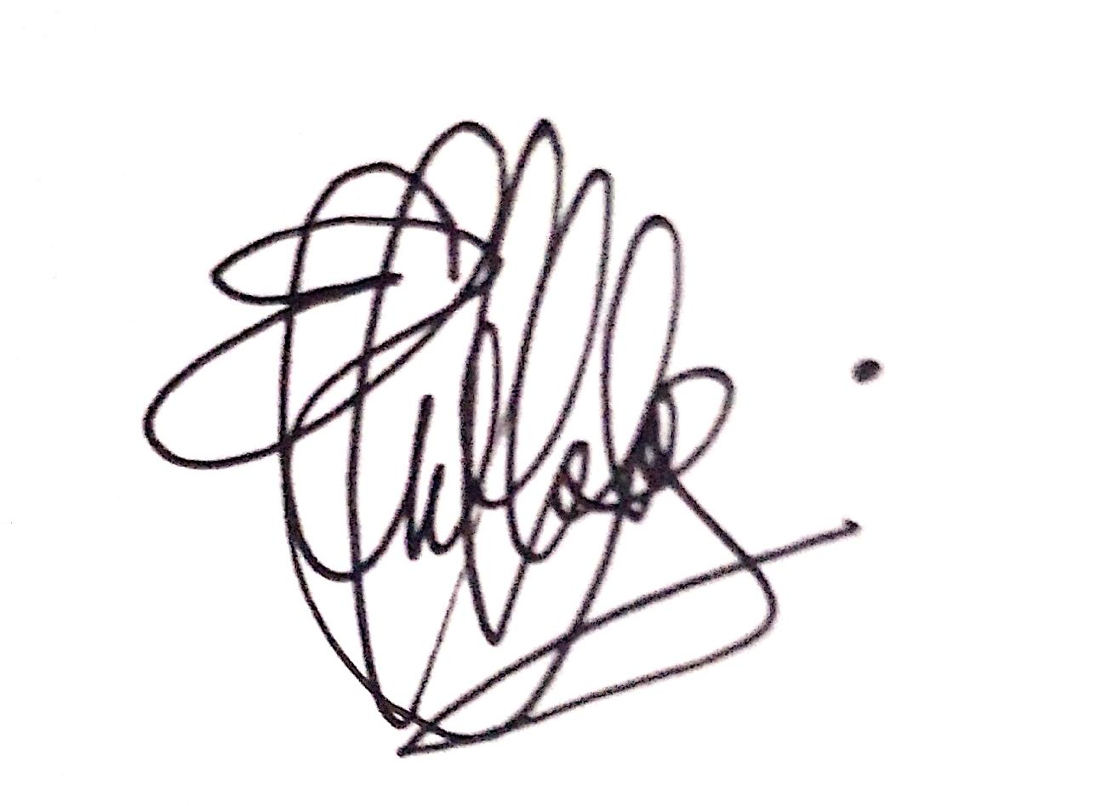
Incumbent Sign-Off
Name: GOLDY GODFREY EFFIONG
Signature:
Date: 2ND APRIL 2026
Line Manager’s Sign-Off

Name: KELECHI GIFT KALU
Signature:
Date: 02/04/2026

